“The universe is not made of atoms.
It’s made of tiny stories.” -Anon

II Storytelling
1. Introduction
Storytelling is an ancient art form that has entertained and informed people across centuries and cultures. It is the instructional potential of stories that continues to serve teachers. Stories in every culture shared as a means of entertainment, education, and preservation of culture and to instill moral values. By doing this, the characters and themes in the stories have become cultural and often cross-cultural models of historic and continuing importance. Even in today’s technological world, the archetypes presented in traditional oral literature are still relevant.
Research has shown that storytelling and dramatization were significantly more effective in facilitating recall of prose content than television. These findings indicated that story telling is a practical method for stimulating children’s imagination, ultimately leading to a higher cognitive level in student’s responses. Researchers have also discussed ways to teach mythic literature to teach children about themselves and to help them write their stories and legends. For very young learners, the sequencing of events or the shaping of stories may be difficult, as children tend to wander in their thoughts.
Like music and dance, storytelling is also a performing art. Telling a story makes the children feel that you are giving them something personal. The power of stories is no doubt immense. Generally storytelling begins in the mother tongue but the power exerted by them is the same even in the other tongues. As a technique for the development of aural-oral skills, storytelling is one of the most effective and powerful stimuli. Listening to stories prepares the young learners to become more accurate in using language for a variety of interactive situations. Students learn to use appropriate words in different styles to express themselves and to explain something. Also, storytelling as a language development technique stimulates a lifelong interest in reading.
2. Why Stories…
Stories, which rely so much on words, offer a major and constant source of language experience for children. We all need stories for our minds as much as we need food for our bodies. We watch television, go to the cinema and theatre, read books, and exchange stories with our friends. Stories are particularly important in the lives of children: stories help them to understand their world and to share it with others. Children’s hunger for stories is constant. Every time they enter the classroom with a need for stories which if fulfilled can transform the spirit of the classroom.
Stories are intrinsically motivating; rich in language experience; and most importantly can satisfy inquisitive nature of children. The best thing about this language rich content is that it is rooted in culture and therefore brings awareness of history and culture among the listeners. Stories have another advantage over other material i.e. they are inexpensive and unforgettable. Surely, stories should be a central part of the work of all primary teachers, whether they are teaching the mother tongue or a foreign language.
Stories play a vital role in teaching a foreign language to children. They motivate children to listen and also provide a purpose for listening that is, finding meaning. The advantage of a story is that it is structured. This helps children to become aware of the sounds of the foreign language and sentence constructions. In addition, stories provide a stimulus for speaking and writing. Most stories can be used to develop children’s power of awareness, analysis, and expression and also can be related to other aspects of the curriculum.

3. How to tell stories to young learners
Storytelling is an interesting and innovative concept that can be used to grab the learner’s attention and acts as an interactive medium for effective learning. Teaching stories aims at improving listening and speaking skills of young learners. The students listen for information and instructions and speak to ask questions and give answers.
For the effective learning of the English lesson, the teacher could choose simple stories with simple themes that are familiar with children’s personal experiences and interests. The teacher can ask questions related to the student’s own experiences, family, toys, which relate the theme or content of the story. The story itself must be entertaining, of high interest value and appropriate to the conceptual and emotional development of the student. The teacher should choose a story that engages the child’s attention from the very beginning and is appropriate for children and suits their mental level. Pictures of the characters, places or objects, which are in the story can be shown for better understanding of the students
Stories chosen with care would enhance their experience of language. Once a suitable story has been chosen, the next step is to plan its telling. The teacher should make the students sit comfortably around in a semi-circle or in front of her. The sitting arrangement and the classroom atmosphere should allow her to have an eye contact and an eye control over all the students present in the class. The teacher should begin the story only after she has everyone’s attention and total silence in the classroom. Moreover, the teacher should be confident enough of how to begin and finish a story.
A storytelling session may generally be planned in three stages:
1. Pre-telling – the stage of preparation before storytelling
2. While-telling- the stage of actual storytelling
3. Post-telling- the stage of winding up
Pre-telling stage includes preparation for storytelling in which the teacher addresses difficult vocabulary and raises the level of curiosity in children by telling them the title of the story. It also includes general prediction about the theme and questions about the characters in the story. Discussion of vocabulary in the pre-telling stage ensures a better comprehension of the story. Keeping in view the age of the students, vocabulary may be presented through pictures and realia or through mime. The teacher may also read aloud and use the cover page and the title to generate some language before telling the story.
While-telling is definitely the most important stage as the story can be divided into first telling and second telling including activities based on listening and speaking. Some memory games using work sheets, pictures and flashcards may also be used to sustain the interest of the students. While telling a story, the phrase ‘Once upon a time’ always catches the children attention. The teacher can look at the students when telling the story. She should try to increase their interest on the story by using gestures, body movements and mime while telling the story. Teachers need to encourage the students to ask simple questions related to the story. Teachers can also give those hints about the story and encourage them to guess the content.
Teachers can encourage the children to predict what is coming next in the story by stopping whenever it seems appropriate and asking what they think is going to happen next. The story should be punctuated by inviting the opinion of the students about the story till that point, their comments on what is happening and has happened so far and lastly, to guess what is likely to happen next or how the story would end. The teacher can receive a personal response of the students by asking them how they would feel or what they do in the situation of the story.
The Post-telling stage is again very important as the children now know the story and it becomes easy for the teacher to practice various linguistic elements present in the story through different activities. Repetition of the key words should be there in the activities so that the students could feel themselves familiar with the words and are able to speak a few sentences based on those words. They can also be asked to draw a picture of a character or a particular situation as a home assignment.
4. Storytelling activities related to the story should be divided in two categories:
- Recognition activities
- Production activities

Recognition activities work better with students at young age because at that time they are not well aware of the content of the story. Moreover, recognition activities provide them with sufficient support that helps them to arrive at the right answer. In post-telling stage, when the students are familiar with the story, production activities work well. It may be a good idea to have more production activities at this stage. Being familiar with the stories, students have more content to talk about and the story content works well to support them while they are trying to negotiate with the form. If the while-telling and post-telling stages are punctuated with appropriate and well-placed activities, it can turn storytelling into a fruitful language comprehension and language generation exercise. The activities in this section are designed for vocabulary building, spelling, and other memory games.
Body movement and facial expressions are also essential for good storytelling. The teacher’s voice is her best and the most creative prop. She can change its pitch, volume, speed and tonal quality to create an appropriate medium for introduction and elaboration of characters and stimulate the imagination of the young listeners. The teacher should begin the story with an explicit introduction with modulated pitch, volume for better expression. Speak loudly enough for the children at the back can hear easily. The teacher should speak slowly and enjoy the words she speaks.
To conclude, stories are very effective material for the development of language skills. Stories help children to develop a positive attitude towards language and also develop their skills of prediction, evaluation while listening to stories, which are essential for comprehension. Stories also help to raise their critical thinking skills while trying to predict and evaluate the story content. They offer calm and stress free ambience in the classroom and encourage effective listening and fluency in speaking. Storytelling in the classroom can provide the learners a rich experience of language that they can generally understand and enjoy.

THE RED PLASTIC RAIN HAT

Level : Beginners
Age : 6 to 9

Learning Outcomes

The students are able to improve
- Listening and speaking skills
- Listening for information and instructions
- Speaking to ask questions and give answers
- Using appropriate words in different styles for better expression explanation.

Preparation

- The lesson plan includes the use of visual aids such as pictures of the various characters, situations and objects included in the story.
- These pictures will be displayed by the teacher on a hard rectangular cardboard sheets and thermocol sheets.
- Other visual aids include:
Using audio-visual aids
Flash cards
Printed worksheets

ACTIVITY 1 (Pre Listening)

INTRODUCTION TO THE STORY

- Introduce the students to Minnie Mouse and tell them about her lost hat.

- Ask the following general questions from the students:

(a) Do you watch cartoons?

(b) Who is your favorite cartoon character?

(c) Do you know who Minnie Mouse is?

Teachers’ corner

Teachers’ Guide

Teacher introduces story to the students by asking general questions. The teacher can also tell the students about his/her favorites cartoon character such as Mickey Mouse or Donald duck. The teacher shows them a picture of Minnie Mouse.
This is a classroom activity. Children will answer the questions put by the teacher by raising their hands

Classroom language:
First of all, tell me a few things.
Do you like to watch cartoons?
I love cartoons. My favorite cartoon character is Minnie Mouse. Look at this picture; this is Minnie Mouse. Today I’ll tell you a story about Minnie Mouse.
Minnie Mouse wants to go out but it is raining.
She wants her red plastic rain hat with coloured flowers on it.
Let us see whether she finds it or not.
I hope you will enjoy it. Shall we start the story? Are you all listening? Listen carefully. After completing the story I will give you some activities based on the story.

Possible answers:

Yes, we do/No we don’t
Mickey Mouse/Minnie Mouse/Tom and Jerry/Donald Duck
Yes, I’ve seen her/ No, I don’t know




The Red Plastic Rain Hat

Minnie Mouse wanted to go out, but it was raining. She put her coat and said to herself, “Where’s my rain hat?” Oh where’s my rain hat? Minnie had a very nice red plastic rain hat with colored flowers on it. She looked in the drawing room and found her books and her toys and her cap—but no rain hat.


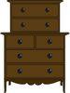
“That’s Funny”, she thought. “Perhaps I put it in my dresser”. Yes, I think I put it in my dresser. She ran upstairs and searched through her dresser. She found her coat, her jacket— but no rain hat.

“Did I put it in my hanky drawer?” she wondered. She opened the drawer and found her feather fan and her earrings and her blue socks and her long string of artificial pearls- but no rain hat.

“I can’t have put it in the shoe rack” she frowned. “No, I didn’t put in the shoe rack”, she said again. In the shoe rack she found her rubber boots, her pink slippers – but no rain hat. “Oh god, no rain hat here also” she said.



“I guess Pluto’s got it”! She said. “Yes, I think Pluto’s got it”, she said aloud and ran to Pluto’s basket. She found nine old bones, a chewed rubber ball and half a slipper— but no rain hat.

“I’ll just have to go without it, then, “she sighed. “Should I go without it then? Said she. It was raining hard now, so she took her umbrella with her. When she opened it, something soft fell out on to her head and it was— Yes! - The red plastic rain hat!

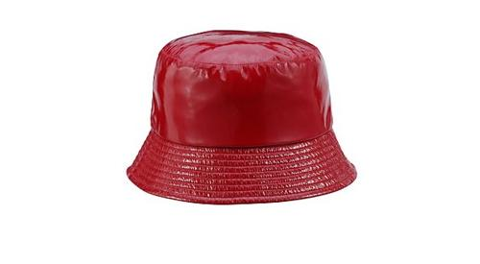

ACTIVITY 2

Vocabulary expansion (Vocabulary through Visual Aids)

Show the students the snap shots on the projector or coloured flash cards of various words to be produced and used in the classroom during the nursery rhyme session.

Key Words:

Coat

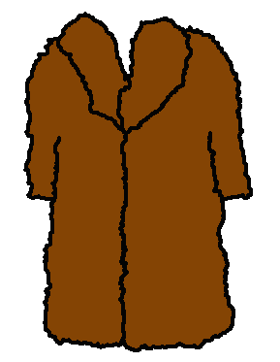

This is the coat, which Minnie Mouse put on herself while going out

Red Plastic Rain Hat

:
Do you know what Minnie Mouse is looking for?
She is looking for this Red Plastic Rain Hat.

Drawing Room



This is Minnie Mouse’s Drawing room. She found her books, toys and cap here, but there was no
Red Plastic Rain Hat

Dresser, Blue socks, Blue coat and Earrings

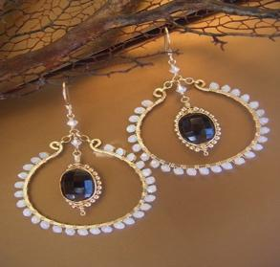

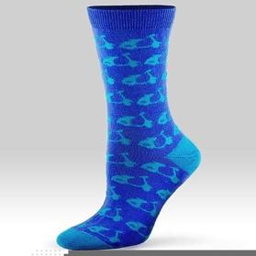

Minnie Mouse ran upstairs. She searched her dresser. She opened her drawers. She found her earrings, her blue coat, blue socks, but there was no
Red Plastic Rain Hat

Coat

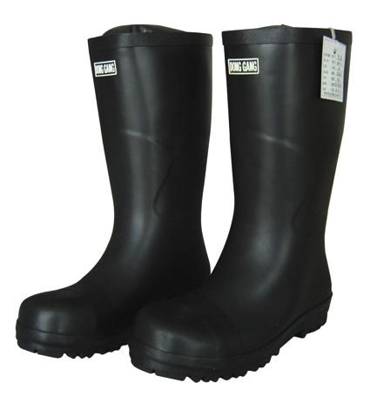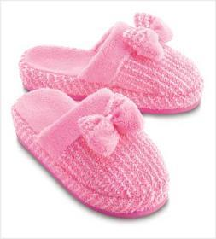

Minnie Mouse was sad. She went to her shoe rack. She searched. She got her rubber boots and pink slippers, but no Red Plastic Rain Hat

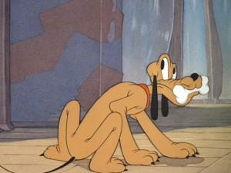

This is Pluto, Minnie Mouse’s pet dog. Pluto is holding a bone. Minnie Mouse thought that Pluto has got her hat. She searched Pluto’s basket, but there was no
Red Plastic Rain Hat

Umbrella



Minnie Mouse couldn’t find her Red plastic rain hat. She decided to take her umbrella instead of her hat. When she opened it, something soft fell out on to her head and it was- yes! - The red plastic rain hat!

Glossary

- Upstairs: up the stairs to or on an upper floor

- Drawer: A box like compartment in furniture that can be pulled out and pushed in

3. Shoe rack: A storage area for shoes

4 Frowned: have an angry look.

5 Raining hard: raining heavily

6 Sighed: breathing sorrowfully, being tired, or relief.

Teachers’ corner

Teachers’ guide The teacher shows the flash cards or snaps shots on the DVD player in the classroom of different pictures in the rhyme and tells the students about the pictures.

Classroom Language - Ok, children, now we will see some pictures and talk about them.

ACTIVITY 3

Speaking (Individual activity – 5 minutes)

Ask the children the following questions and tell them to raise their hands if they know the answer. Discuss the questions in class.

- What is the story about?

- Give a list of things Minnie finds in the story

- Where does she find her hat?

Teachers’ corner

Teachers’ guide: The teacher stands in front of the class and asks some questions related to the story. Students raise their hands and all the questions are discussed in the class.

Classroom language:
I’m going to ask you some questions about the story.
Raise your hand if you know the answer.

Answers

(a) The story is about Minnie Mouse. She is searching for her red colored rain hat with colored flowers on it. She searches in her drawing room, dresser, hanky drawer, shoe rack, Pluto’s basket and at last she finds it while opening umbrella.

(b)She finds books, toys, cap, coat, jacket, feather fan, earrings, socks, string of pearls, rubber boots, pink slippers, nine old bones, chewed rubber ball and half a slipper

(c) She finds her hat in the umbrella

ACTIVITY 4

Listening: (Group activity – 5 minutes)

Ask your students to fill the boxes according to the things Minnie Mouse finds in the drawing room, the dresser and the hanky drawer.

Drawing room | Dresser | Hanky drawer

Toys, socks, earrings, coat, books, jacket, cap, feather fan

Teacher’s corner

Teacher’s Guide
The teacher draws a table on the board and asks ten students to come in front. Teacher provides flash cards of the words to the students which are to be sticked on the table in the suitable boxes.
Students take their turns and fill the boxes.

Classroom language
Okay children, we’ll do an activity. Look on the board, I’ve drawn a table. You will fill the boxes according to the things Minnie Mouse finds in the drawing room, the dresser and the hanky drawer.
I’ll call you one by one to come up and place these cards in the boxes where Minnie mouse found them.

Answers
Drawing room: books, toys, cap;
Dresser: coat, jacket;
Hanky drawer: feather fan, earrings, socks

ACTIVITY 5

Vocabulary & Speaking: (group activity- 10 minutes)

The children will make simple sentences of each the following words. They will also share the sentences they had made with the class. Some students may be called upon to write the sentences on the board. student can write all the sentences spoken and paste them on the board.

- Flowers
- Books
3. Toys
4. Umbrella
5. Hat

Teacher’s corner

Teacher’s Guide:
The teacher picks up five words from the story and writes on the board. She asks the children to make different sentencing by using those words..He/she can give some hints to the students from the story itself or from routine life.

Classroom Language
Now we’ll do another exercise. I’ve written five words from the story on the board. Each one of you will make a sentence of the given words. I’ll give you one example, like for flowers, we can say ,”I love flowers”, “I have two umbrellas”. Like those you will make the sentences. When you are done, we will discuss. Okay Class.

Answers

1 Flowers: Children were plucking yellow flowers from the garden.
2. Books: I have many books in my bag.
3. Toys: I share my toys with my friends.
4 Umbrella: I have a pink umbrella.
5. Hat: I love my blue hat.

Second Unit

Activity 6

Listening: (Individual activity- 5 minutes)

Let the children complete the words in given boxes according to what Minnie Mouse finds in the shoe rack and pluto’s basket.

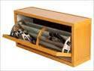  I. Shoe rack | 1. rubber  ________ | 2_________  Slippers
  II. Pluto’s Basket | - chewed  ___________ | 4 _____________  old bones | 5.half a  _________

Teacher’s Corner

Teacher’s Guide

The teacher draws a table with missing words. She stands in front of the students and asks them to come in the front and write in the blanks those things that Minnie mouse finds in the shoe rack and pluto’s basket.

Classroom Language

Let’s do another board activity. I’ve made a table on the board. Do you see the pictures? The first is a shoe rack and second is pluto’s basket. You will fill the boxes with the things Minnie mouse finds in shoe rack and Pluto’s basket. The first part of the word is given and you will fill the rest of it.

Answers

1: boots, 2: pink, 3: rubber ball, 4: nine, 5: slipper

Activity 7

Speaking (group activity -10 minutes)

Ask the children to describe the picture given below. You must give some hints to the students to help them describe the picture.

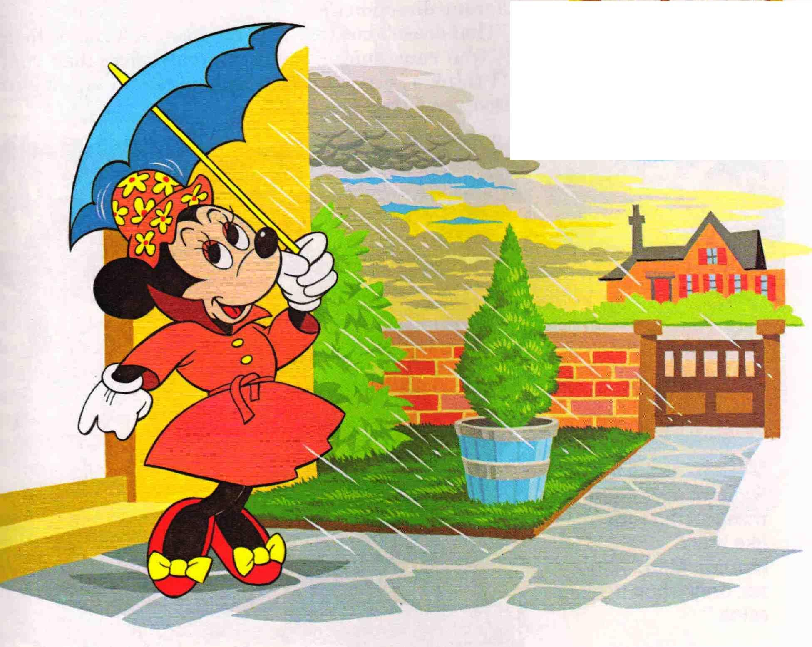

Teacher’s corner

Teacher’s Guide

Teacher hangs the picture pasted on a cardboard sheet on the board. She divides the class into groups. Teacher gives hints to the student who comes from each group to speak a sentence on the picture. It is a guided task. Teacher will spend time with each group when they are preparing for the activity.

Classroom Language

Let’s do an interesting activity. I’m going to show you a picture. From each group one student will come up and speak one sentence on the picture. How many rows of students are there in this room? Yes, there are five. Now students sitting on the first three/four benches of each row will be in one group. Each student sitting in the last three/four benches will form other group. So, we will have ten groups in the class. Is it done? You can take help of the hints given on the blackboard for making sentences

Teacher writes the following hints on the board

Setting of the scene- inside/outside of the home.
Who is holding umbrella?
Colour of umbrella.
Clothes she is wearing
Colour of clothes

Activity 8

Listening & speaking (Individual activity -5 minutes)

Where did Minnie search for her hat?

Children will arrange the places in the order they occur in the story.

Dresser, Drawing room, hanky drawer, shoe rack, pluto’s basket.

Drawing room, …………………, ………………., …………………, ……………………..

Teacher’s corner

Teacher’s Guide

Teacher writes different places given in the story on the board. She asks all the students to arrange the places in the order they occur in the story. After they have done this, ask them questions about these places. Ask the same question for at least three students for reinforcement.

Classroom Language

See, I’ve written the names of five places where Minnie searches for her hat. You have to arrange the places in the order they occur in the story. I’ve done one for you. Shall we start ?

Answers

Drawing room, Dresser, Hanky Drawer, Shoe rack, Pluto’s basket

Activity 9

Speaking (Group activity – 5-10 minutes)

Ask the children to play the following memory game in groups. Show them some pictures and then hide them. Ask them to describe some of the pictures they remember.



Teacher’s corner

Teacher’s Guide

Teacher hangs eight pictures of the story on the wall on cardboard sheets. She gives some time to the students to look at all the pictures carefully. After some time she removes some of the pictures and students have to remember that which picture is missing or which one has been removed.

Classroom Language
Now I’m going to show you some pictures related to the story. Carefully look at all the shown pictures .I’ll remove some of the pictures. You will have to guess which pictures have been removed.

Activity 10

Listening (Individual activity -5 minutes)

Let the children match the following places with the things Minnie Mouse finds at different places.

Place Things

1. Dresser 1. Books, Toys, Cap

2. Drawing room 2. Coat, Jacket

3. Pluto’s basket 3.Rubber boots, Pink slippers

4. Shoe rack 4. Feather fan, earrings, blue socks

5. Hanky drawer 5.Nine old bones, chewed rubber

ball, half a slipper

Teacher’s corner

Teacher’s Guide

The activity will be done on the blackboard. The teacher will draw a table on the board and writes names of five places and different things in five points on the board .The students will match places with appropriate number of the given things by taking turns. Teacher asks for collective response from the class if the student does not do it right.

Classroom Language

See children, I’ve drawn a table with places and things related to the story you have read. You have to match the places with appropriate number of the given things.

Answers

1-4, 2-1, 3-5, 4-3, 5-4

Activity 11

Speaking (Individual activity -10 minutes)

Have your students invent sentences with the help of word web of related words from the story.

Minnie mouse

Hat

Coloured flowers

Teacher writes a sentence with the help of this word web as

Minnie mouse has a hat with coloured flowers on it.

2)

Dresser

Coat

Jacket

3)
Shoe rack

Rubber
boots
Pink slippers

Pluto’s basket
4)

Nine
old bones
Half a slipper
Chewed rubber ball

5)

Feather fan

Earrings

Hanky drawer

Blue socks

Artificial pearls

Teacher’s Corner

Teacher’s Guide

Teacher draws a word web on the board. She asks students to make a simple sentence with the help of these words. After getting their response, she makes sentence out of those words as an example for the students. Teacher makes more word webs for their practice.

Classroom Language:

Now let’s make some sentences. Can you see these words in circles? Make one simple sentence of the words given in circles. First I will do for you. Look at the words in the first web, these are Minnie Mouse, Hat and Colored Flowers. The sentence I’ve made by using these words is Minnie mouse has a hat with colored flowers on it.
Lets make more sentences.

Answers (There can be different possibilities)

2. Minnie mouse finds coat and jacket in dresser.
3. She finds rubber boots and pink slippers in shoe rack.
4. In Pluto’s basket she finds nine old bones, chewed rubber ball and half a slipper.
5. She finds feather fan, earrings, blue socks and artificial pearls in
hanky drawer.

Activity 12

Speaking (group activity – 5-10 minutes)

The students will retell the story with the help of pictures given below.

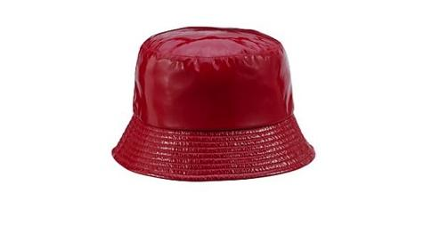

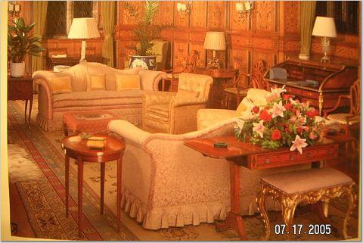

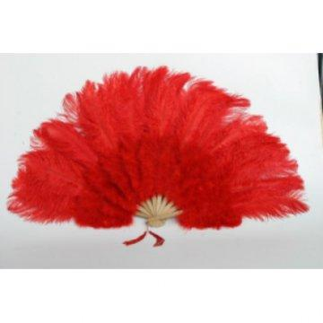

Teacher’s corner

Teacher’s Guide

Teacher shows eight pictures related to the story on a chart paper in the order in which they occur. Class is divided into groups according to the number of the students. From each group one student speaks one sentence on each picture according to their turn and in this way by doing group activity, the story comes to an end.

Classroom Language

Do you see eight pictures of the story on a chart paper. I’ll divide the class into eight groups and one student from each group will come up and make a sentence on the picture. See the pictures carefully then make simple sentences. You will speak your sentence loudly so that everyone can hear.

Answers

Picture 1. This is a story of Minnie mouse
2 She has a red plastic rain hat
3 She searches for her hat in the drawing room
4 She finds coat in her dresser
5 In drawer she finds a feather fan
6 She finds rubber boots in shoe rack
7 In pluto’s basket she finds nine old bones
8 She finds her red hat in umbrella when she opened it.

Activity 13

Speaking (Individual activity -5-10 minutes)

Home Project

The students will draw a rainy day as a home assignment and speak about it in class the next day.

